Traffic Simulation Report

# Part 1: Traffic jams on a circular road

## State visualization

Let’s see how our state over time looks like at different densities. We will use 50 sites as the length of the road and let cars only move from left to right. When the density is very low (4% of sites occupied), we can see in Fig. 1 that there is pretty much no congestion is a short timeframe of 10 steps. This is because there is a large enough gap between the cars, allowing them to flow freely without having to slow down one another.

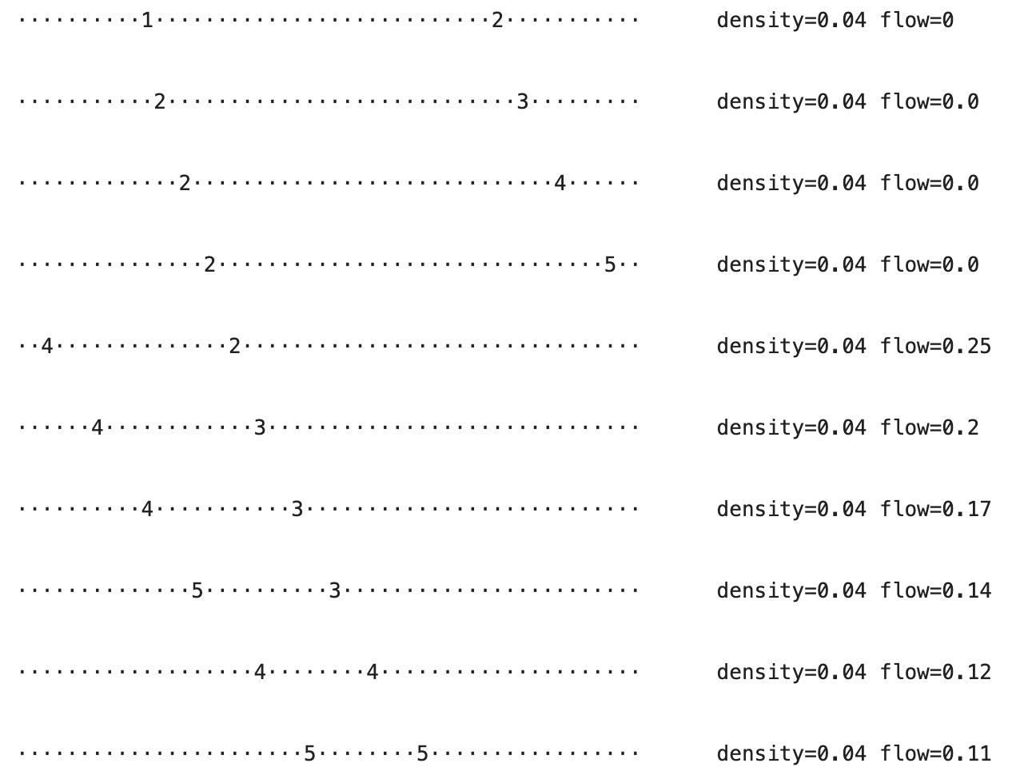

Figure 1

At a slightly higher density of 0.1, we can start seeing some congestion behavior, like in Fig. 2. We can notice that the cars were quite spread out in the beginning but closer to the end, they clumped up at the back. Some cars even had to reduce their velocity to zero, indicating a full stop.

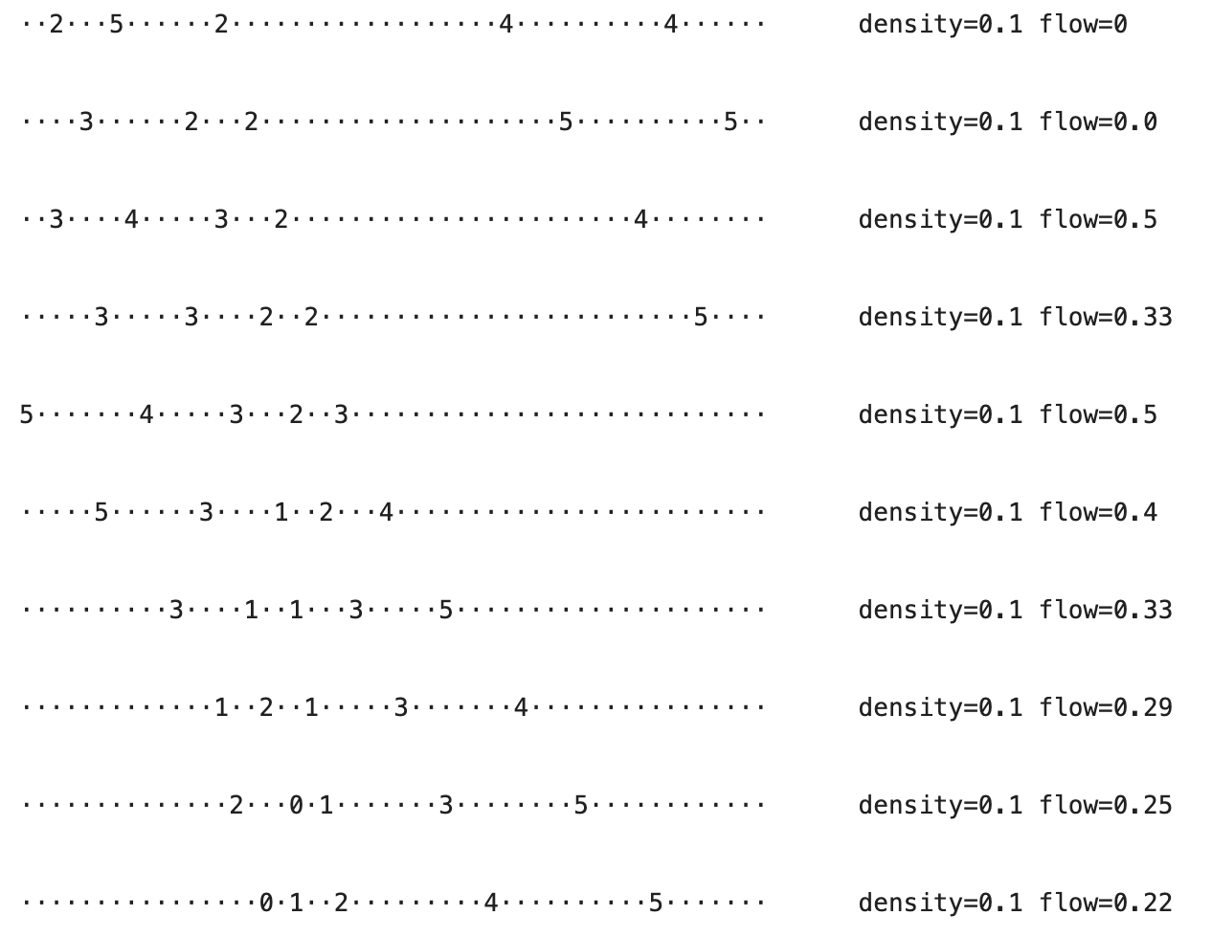

Figure 2

At even higher density, we notice an interesting behavior. The traffic jam seems do be doing a moonwalk (moving backwards) like in Fig. 3. To clarify, the patch of zeroes seems to move from right to left, opposite to the direction of movement. This is because when the car in front slows down, it creates a shock wave that propagates towards the back because the reaction time is not instantaneous. To simply put it, when someone in front slows down, the person behind slows down, then the person 2 cars behind slows down, etc. When the first car starts moving again, the next car starts moving with a delay. This causes the traffic jam to shift backwards relative to the direction of advancement.

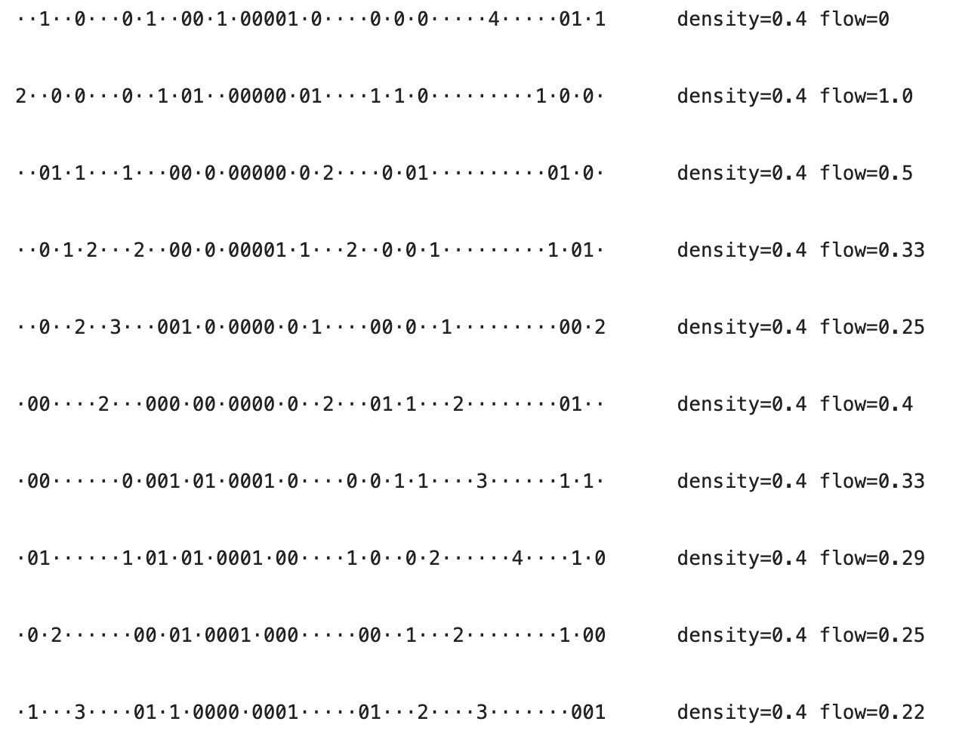

Figure 3

## Flow analysis

We define flow as the average number of cars that pass through a defined point in one timestep. We can calculate this by counting the number of cars that pass through a point (in this case, I chose to use the boundary) and divide by the number of total timesteps. We would like to take a look at how flow changes when density is altered.

For this flow approximation to work, we need to run the simulation for enough iterations; in this case, I chose to run 400. Since we cannot afford to run infinitely many iterations, we can also re-run simulations multiple times to see the spread of average flows; in this case, I chose to run 20 for each density. Density will be varied from 0 to 0.8 with 50 steps in-between to catch interesting inflection points. Fig. 4 displays the output of the calculated flow for many simulations.

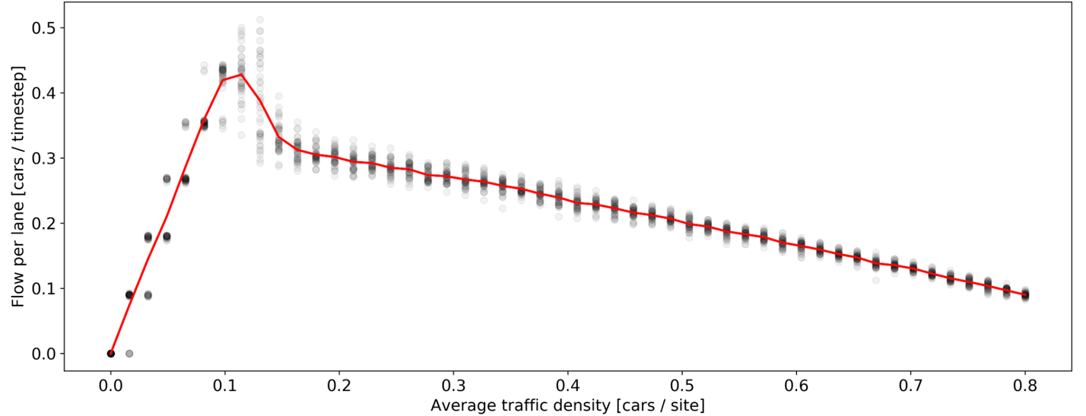

Figure 4

We can notice that in Fig. 4, the flow initially rises and then slowly drops. This can be explained by the fact that when the density is small, it is too small that not many cars pass through the boundary per timestep because they are so spread away. As we increase the density, the number of cars that pass per timestep increases. After the density of about 0.12 in the graph, the flow drops slowly because when there are many cars, there is a higher chance that at least one of them will slow down randomly and cause a traffic jam discussed above. After the peak point, the more cars there are, the more traffic jams we will likely have, hence, the flow is lower.

At the best selected traffic density, the estimated flow is about 0.42, meaning that 0.42 cars cross a site per timestep. This can be converted to period which indicates that one car passes a site for about every 1/0.42 = 2.4 seconds.

# Part 2: Multi-lane highways

## Model description

The multi-lane model introduces an extension to the single-lane (circular) traffic model seen in part 1 by implementing multiple lanes and allowing cars to switch between them. There are a few key assumptions to this model:

* Cars can only switch to the next lane (e.g., cannot jump 2 lanes) at 1 timestep
* All cars, given availability of a switch place on another lane, will switch with the same probability
* Cars do not rationalize the switch: when switch is available, they will switch with a pre-defined probability
* Road lanes are of equal length and share the same maximal velocity

To initialize this multi-lane model, there are a few parameters we must declare:

* Number of lanes (roads) in the model (default is 2)
* Probability of switching lanes for each car (default is 0.5)
* All parameters of single-lane simulation (road length, traffic density, maximal velocity, probability of slowing down)
* Optionally, we can also choose whether we want to summon the cars randomly or evenly on all roads in terms of the density (default is non-uniform)

The update rules of this model are a superset of the update rules of the single-lane model. The switching is assumed to be done before the velocity update. In this model, each timestep includes all three operations: advancement to the next position, switching, and velocity update. The rules used in this implementation are:

* For each car at location with velocity on lane , the availability is checked on lanes (if exists) and (if exists)
* Availability means that on the lane we want to move to, all sites are empty in the range from 5 slots behind the current location to slots in front including ends. In other words, must all be empty
* When there is one lane to switch to, if it is available, the probability to switch to that lane is
* Where there are two lanes to switch to, one of them is chosen at random with equal chances, and the probability to switch, , is applied to it
* All the rules of the single lane apply to this model

## State visualization

We apply the same densities from the state visualization of the single-lane model to a 2-lane model to observe the behavior. In Fig. 5, we can observe that where there are not many cars, congestion does not form as well. Because there is low density of cars, we can also see that there are lane switches relatively often (a subset of those can be observed through the change in densities of roads). Because the cars switch independently and ignore the densities of the roads, we can see an interesting behavior that in the last step two cars switch in the same step, even though densities are even on both sides.

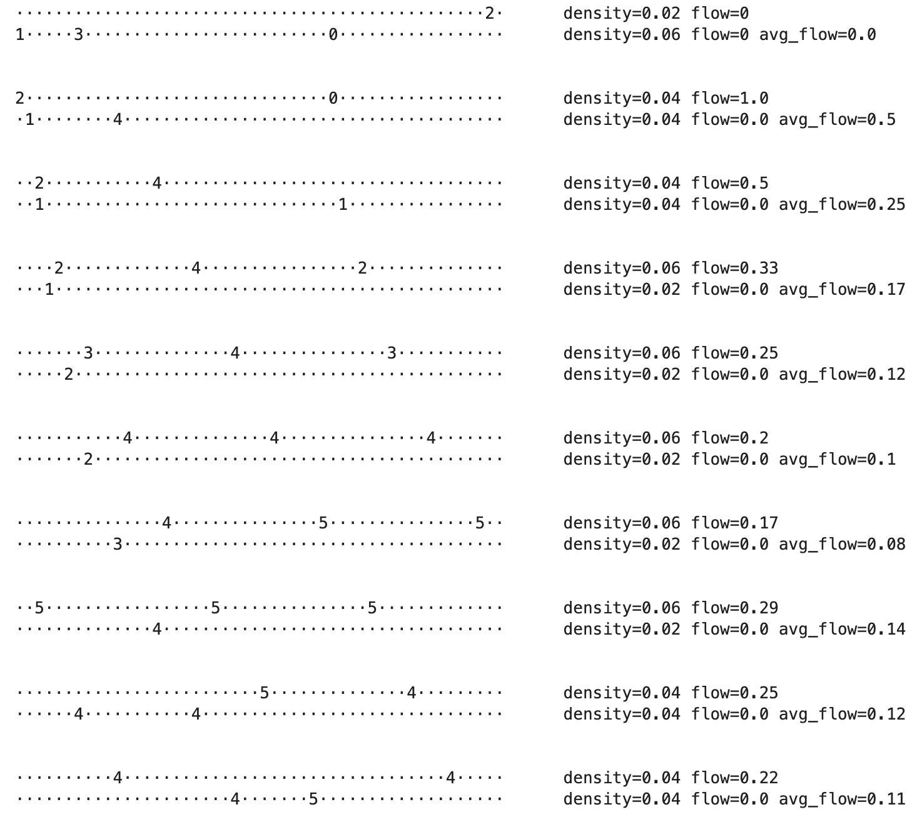

Figure 5

At a slightly higher density of 0.1, we can start seeing cars piling up (Fig. 6) like with the single-lane model. The lane changes are still relatively frequent, as indicated by the change in densities.

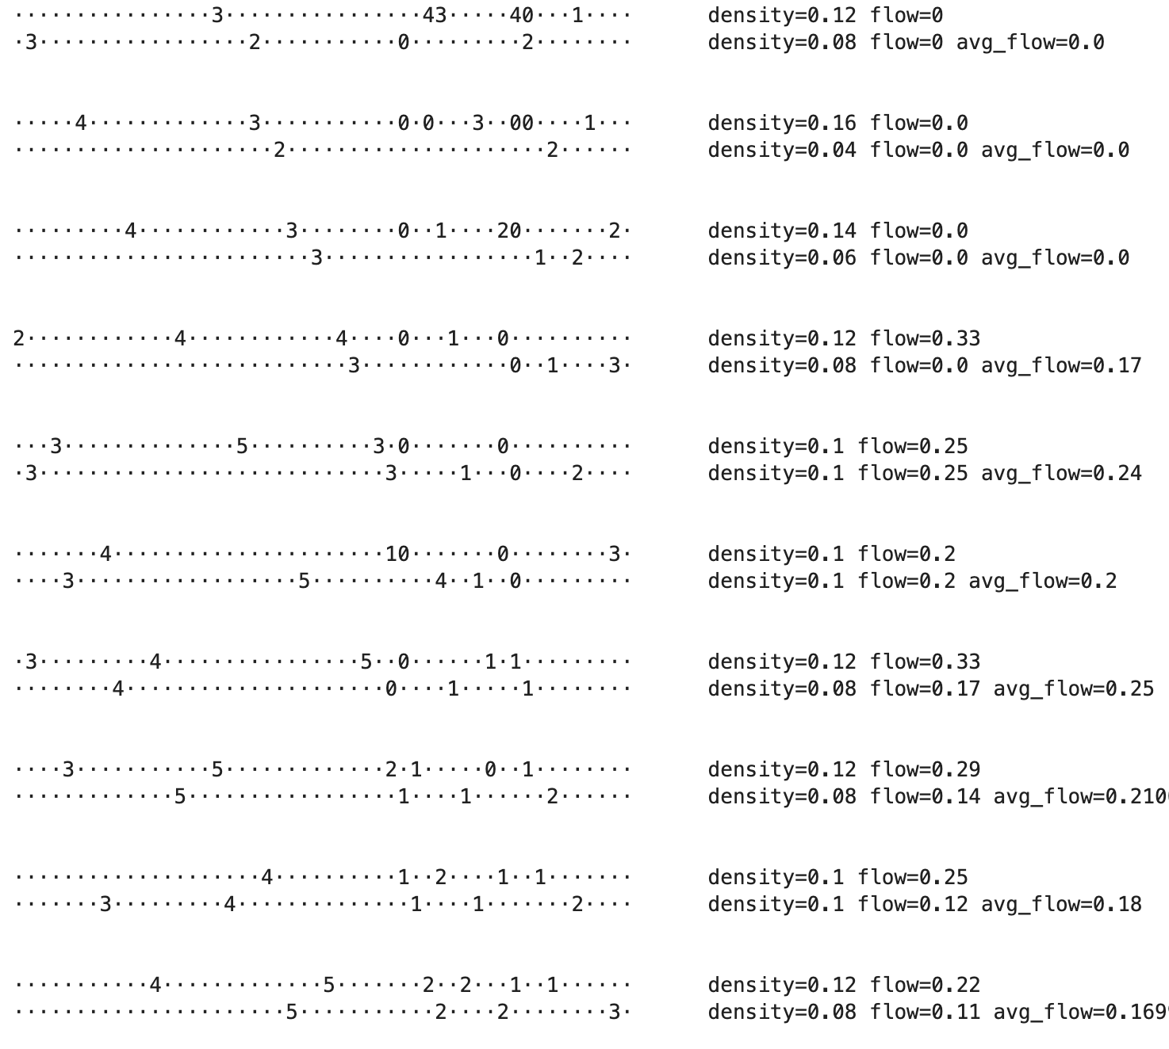

Figure 6

At higher density of 0.4, we can again observe the pattern of a traffic jam traveling backwards (Fig. 7). Additionally, we can see that over time, the density change slows down or stops changing because cars pile up, and thus, the condition for lane switch is not met. The overall behavior resembles that of the single-lane model, which we will compare more in depth in “Key questions” section.

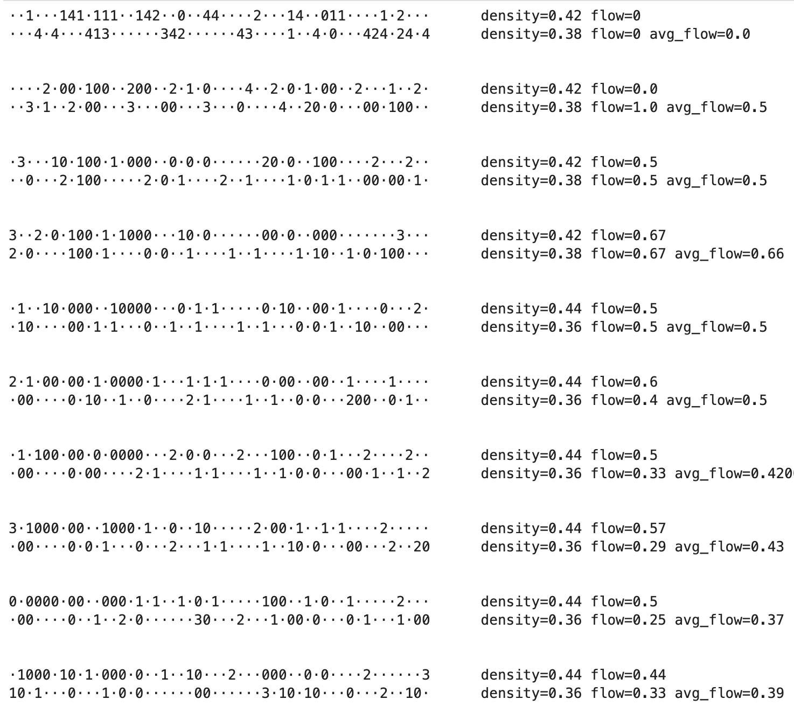

Figure 7

## Flow analysis

To make the flow comparable to the single-lane situation, we will use the average flow of the roads as a measure of flow. We run the simulation on the same parameters as previously for densities from 0.0 to 0.8. In Fig. 8, we can observe a very similar behavior to the single-lane case where the flow seems to rise quickly as the density increases until the peak at density of 0.12. After that, the density steadily drops. This makes sense because even though cars switch lanes, the lanes that are denser will have will have a slightly higher/lower flow depending on the density whereas the lanes that are less dense will have a slightly lower/higher flow. The only part where the flow could change a bit is at the peak part where potentially the flow of 2 lanes could be lower because the densities of roads are on two sides of the peak. We will explore this in the comparison to single-lane section next.

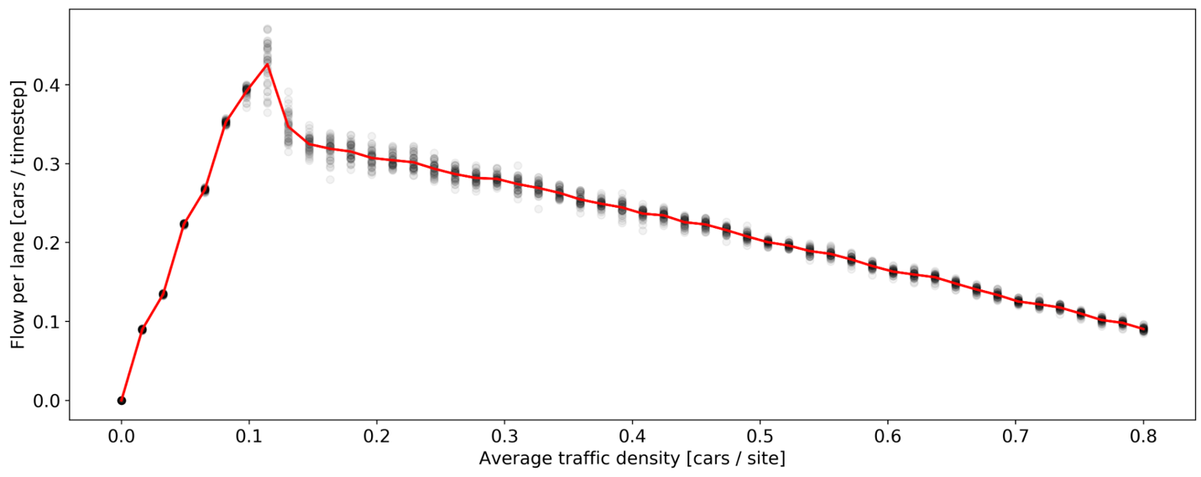

Figure 8

# Key questions

## Comparison to single-lane

Let us run the flow measurement simulation for single-lane, 2-lane, and 3-lane traffic models. In Fig. 9, we capture the means of the flow over densities. As we can see, the single-lane seems to perform the best when it comes to the peak density. This is because when there is lane switching, the densities can be uneven leading to the average flow being the average of densities that are around the peak (which are lower than flow at the peak density). This effect can be observed more strongly in the 3-lane model where there are more switches and potentially higher unevenness of the densities of road lanes.

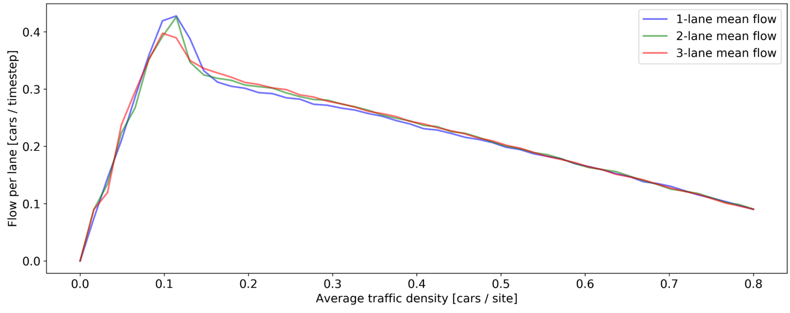

Figure 9

What is interesting is that we see in Fig. 9 after the peak point, the 3-lane model seems to consistently have a higher flow than the 2-lane which is higher than the single-lane model. This could indicate that with 3 lanes, there is a higher chance of getting a low enough density near the peak to achieve a spike in the flow. In the 3-lane model, this applies specially for upper and lower lanes where there is only one option to change, while in the middle since lane there are two options; this means that the upper and lower lanes are more likely to be emptied out. Therefore, one of them is likely to bring that flow spike.

In Fig. 10, we can analyze how consistent the flows in models with different number of lanes. To do this, we take the 95% confidence interval for each density for which the flow is simulated. We can observe in Fig. 10 that the 3-lane model seems to have the narrowest confidence interval, while the single-lane model has the widest confidence interval – all throughout all densities. This indicates that the flow of 3-lane model, on average, is more consistent and predictable for the same density than in single-lane or 2-lane models. This could probably be explained by the fact that in 1-lane situation, when there is congestion, the flow will surely decrease, and the instantaneous flow measurement would be 0 for several timesteps. On the other hand, in the 3-lane model, even if the instantaneous flow is 0 in one lane, the cars can still move on the other lanes, creating a net-positive flow.

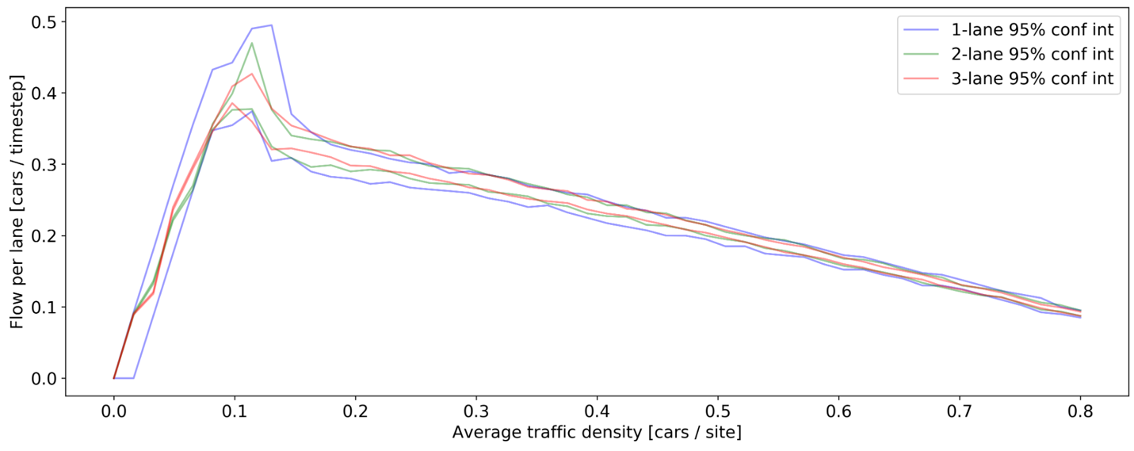

Figure 10

Overall, we see that the single-lane model peaks better in terms of flow both at the mean and at the upper range of the confidence interval, whereas multi-lane models tend to be slightly worse in the mean and narrower in the confidence interval. This implies that if we know for sure that the car density is always at around 0.12 (which does not happen often in a real world), we should employ the single-lane model. On the other hand, if we want the flow to be predictable and on average higher for densities larger than 0.12, we should opt for 2-lane or 3-lane models. Even with a slightly worse performance at the peak density, the predictability allows for prediction of influence of other events (e.g., weather events, what if we put a road construction) which is more beneficial for later on simulations.

## Applicability to Buenos Aires, Argentina

Buenos Aires sports large roads with multiple lanes, often with three lanes. Smaller (local) roads tend to be single-lane. This makes sense because on highways, we expect to house more cars and expect stability in terms of the flow. On the smaller parts of the city, single-lane roads are, of course, cheaper, but also perform just as well as 2- or 3-lane roads when the density is low. We should also take into account the absolute number of cars because the flow we are measuring here is average per lane. If there is not much demand, single-roads are cost-effective and provide a good flow.

## Future work

This traffic system model is represented by a cellular automaton with abstract and simple update rules that apply to every single car. While it does show some dynamics that happen in real life, such as traffic shockwave traveling backward, it lacks certain details to simulate the actual traffic. There are various extensions we can apply to the model to make it more suited for simulating real traffic:

* Increase the resolution for sites, car size, car velocity. For example, instead of 1 site as approximately 5 meters (length of a car), we can use 1 site as 0.5 meters, so a car would take up 7-50 sites depending on car model. This would also allow for more granularity in terms of the velocities they move at
* Add randomness to all inputs and outcomes. For example, the slowing down does not have to be by 1 unit but it can be sampled from a positive-cropped normal distribution with mean 1 and some variance. At initialization, cars can be initialized with random lengths, shortest cars are 3.5 meters and large container trucks can be 25 meters. The probabilities (of slowing down or changing lanes) can also be randomized since drivers behave differently, and container trucks are less likely to switch lanes
* Introduce velocity estimation by each driver. In a realistic scenario, at timestep , we don’t move until where the car in front of us at timestep . Instead, we can estimate their velocity are try to follow them. We can then modify the condition where we look for the car in front: instead of keeping the velocity less than the current distance, we can put it as
* In terms of the metrics used, in addition to flow, we can measure the average velocity of each car and the number of significant slow-downs they have (e.g., more than ). This way, we can understand directly what would the driver experience be like, will they have to constantly stop, can they drive at high velocity through the highway